ECE 5554 SU22 – Dr. Jones – HW3

**Part 1d and 1g: Console Output**

Top 3 corners using cv2.goodFeaturesToTrack

Filename: AllmanBrothers.png

(x,y): (246.0,39.0)

(x,y): (530.0,230.0)

(x,y): (628.0,68.0)

Top 3 corners using Harris Corner Method

Filename: AllmanBrothers.png

(x,y): (529,229)

(x,y): (495,77)

(x,y): (246,39)

Top 3 corners using cv2.goodFeaturesToTrack

Filename: CalvinAndHobbes.png

(x,y): (470.0,519.0)

(x,y): (422.0,556.0)

(x,y): (293.0,541.0)

Top 3 corners using Harris Corner Method

Filename: CalvinAndHobbes.png

(x,y): (538,380)

(x,y): (199,499)

(x,y): (532,454)

Top 3 corners using cv2.goodFeaturesToTrack

Filename: Chartres.png

(x,y): (307.0,748.0)

(x,y): (319.0,744.0)

(x,y): (318.0,680.0)

Top 3 corners using Harris Corner Method

Filename: Chartres.png

(x,y): (299,745)

(x,y): (315,750)

(x,y): (326,747)

Top 3 corners using cv2.goodFeaturesToTrack

Filename: Elvis1956.png

(x,y): (579.0,411.0)

(x,y): (616.0,426.0)

(x,y): (577.0,399.0)

Top 3 corners using Harris Corner Method

Filename: Elvis1956.png

(x,y): (617,426)

(x,y): (580,411)

(x,y): (592,425)

**Part 1e and 1h: Draw circles using both methods**

cv2.goodFeaturesToTrack Method:

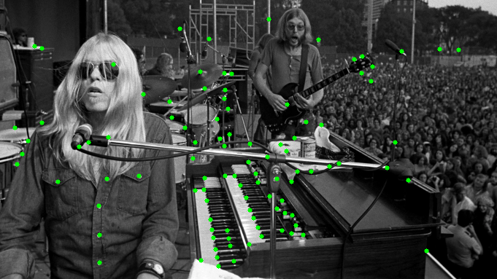

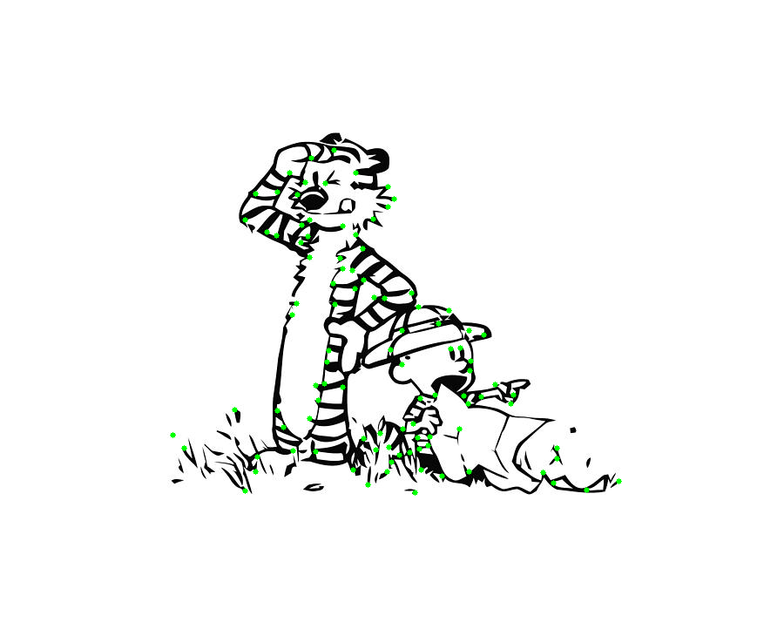

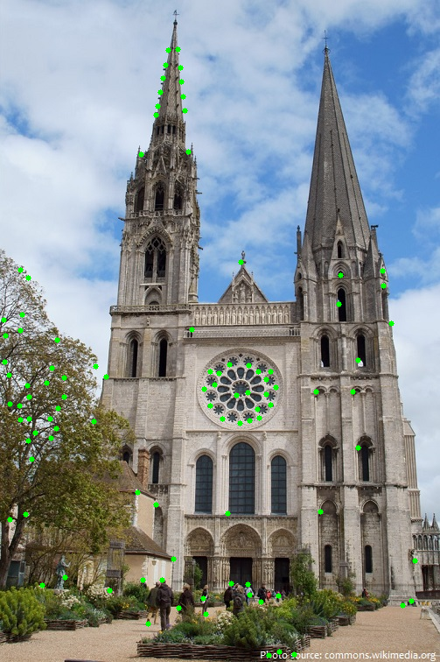

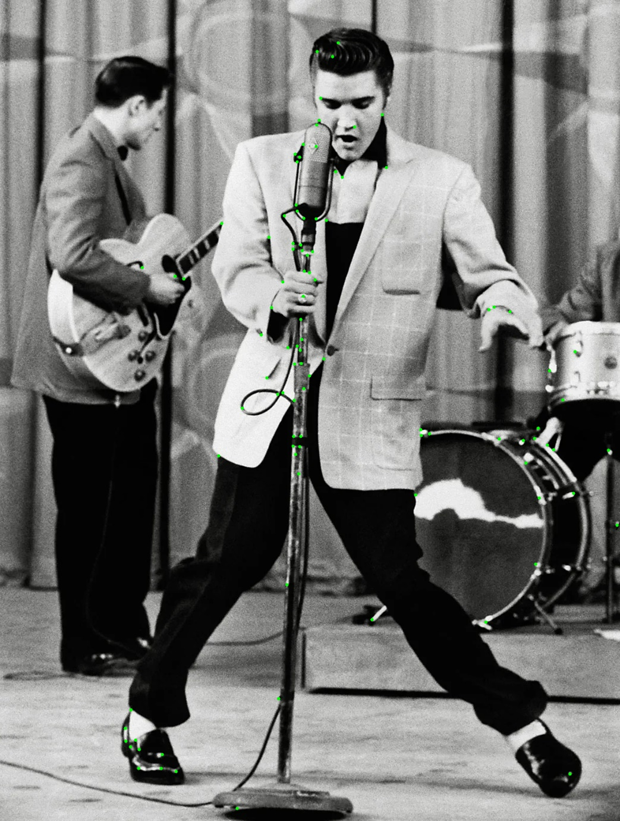

Implementation of Harris Corner Detector:

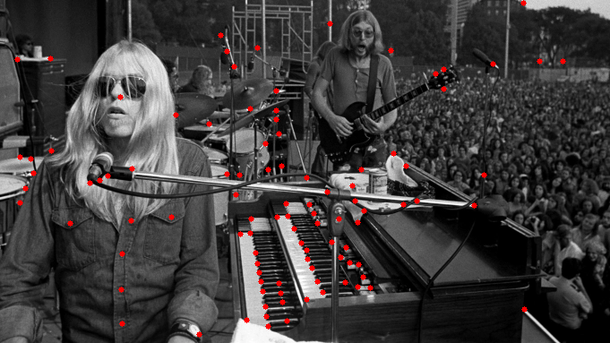

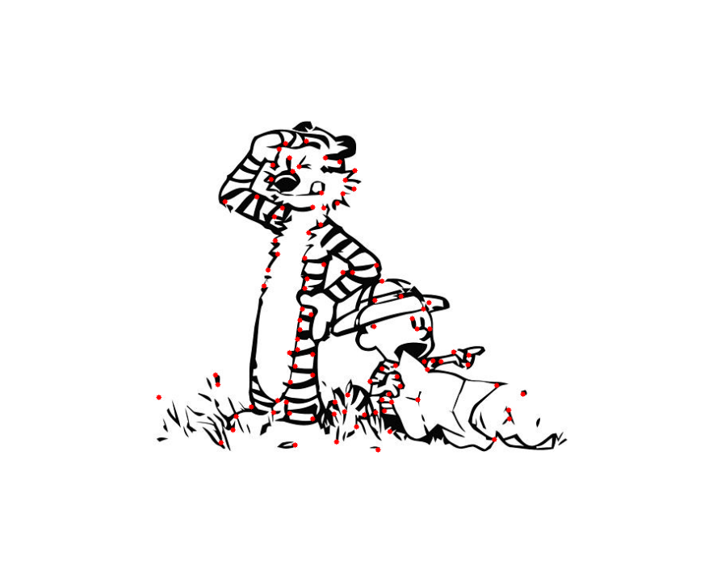

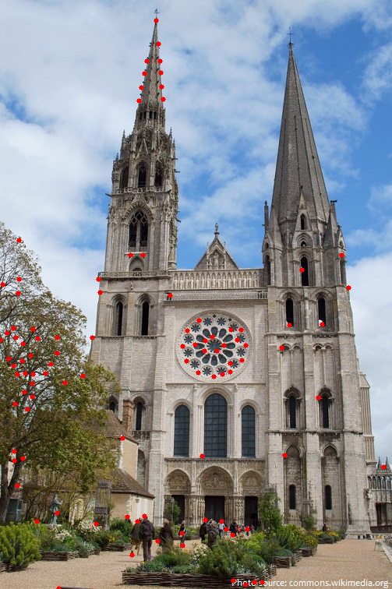

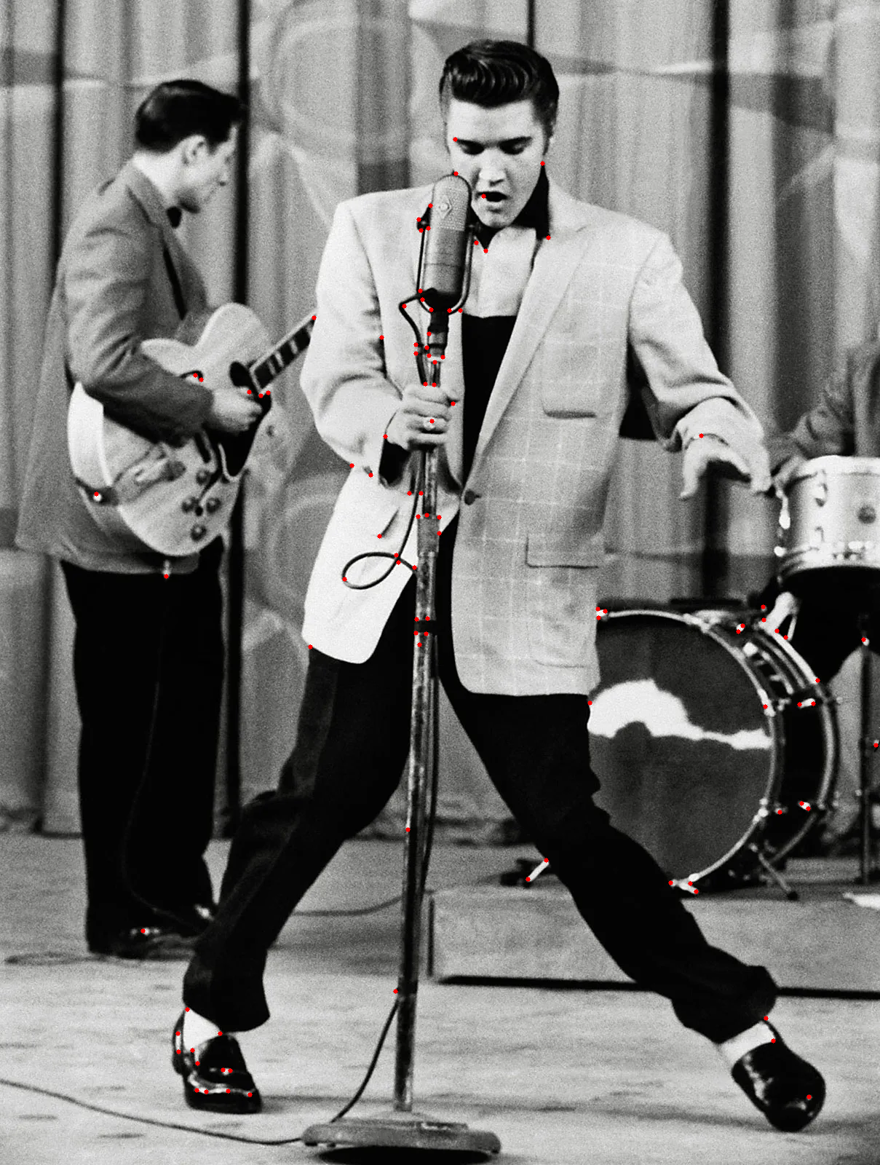

Side by side:

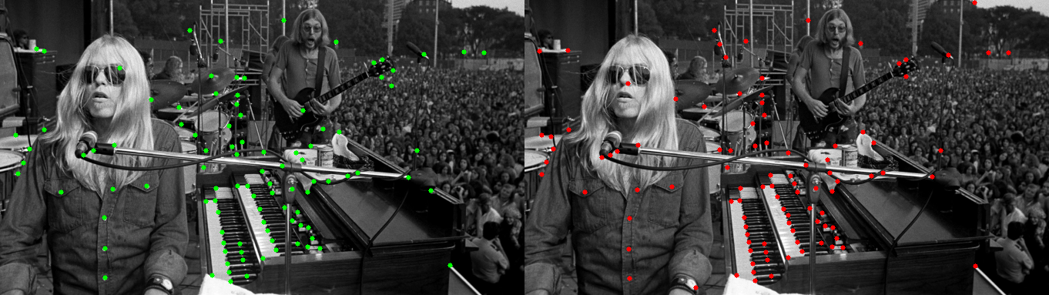

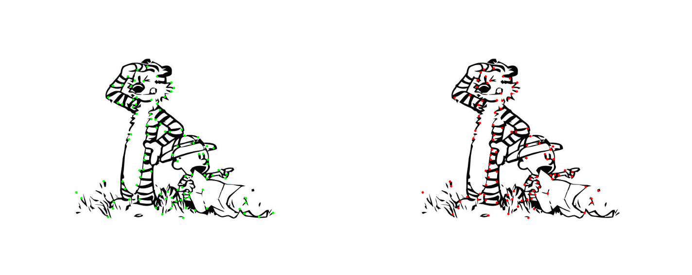

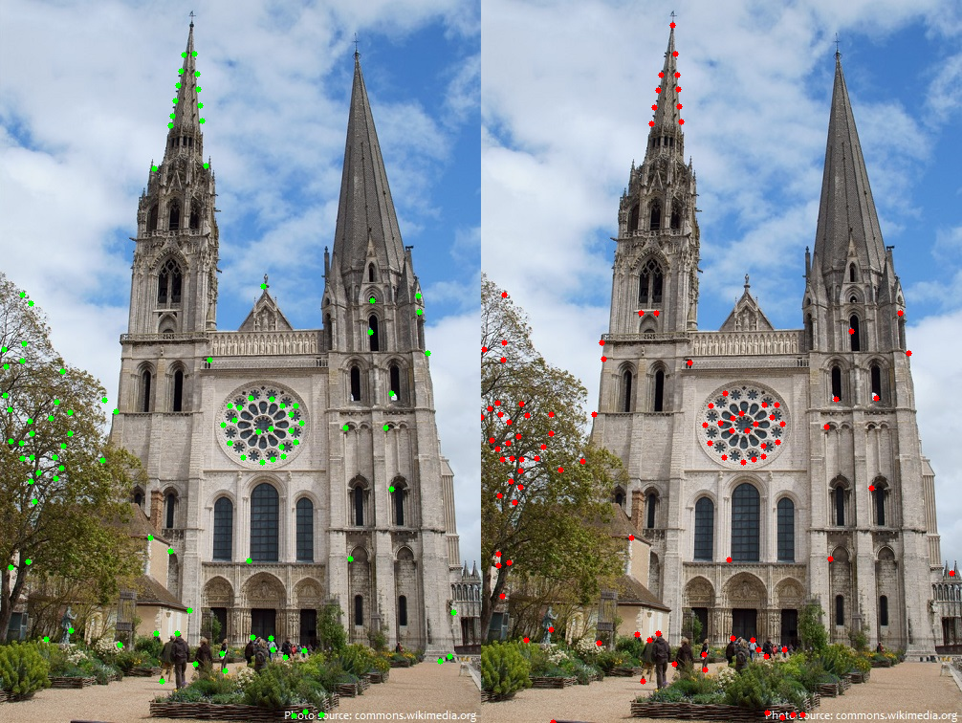

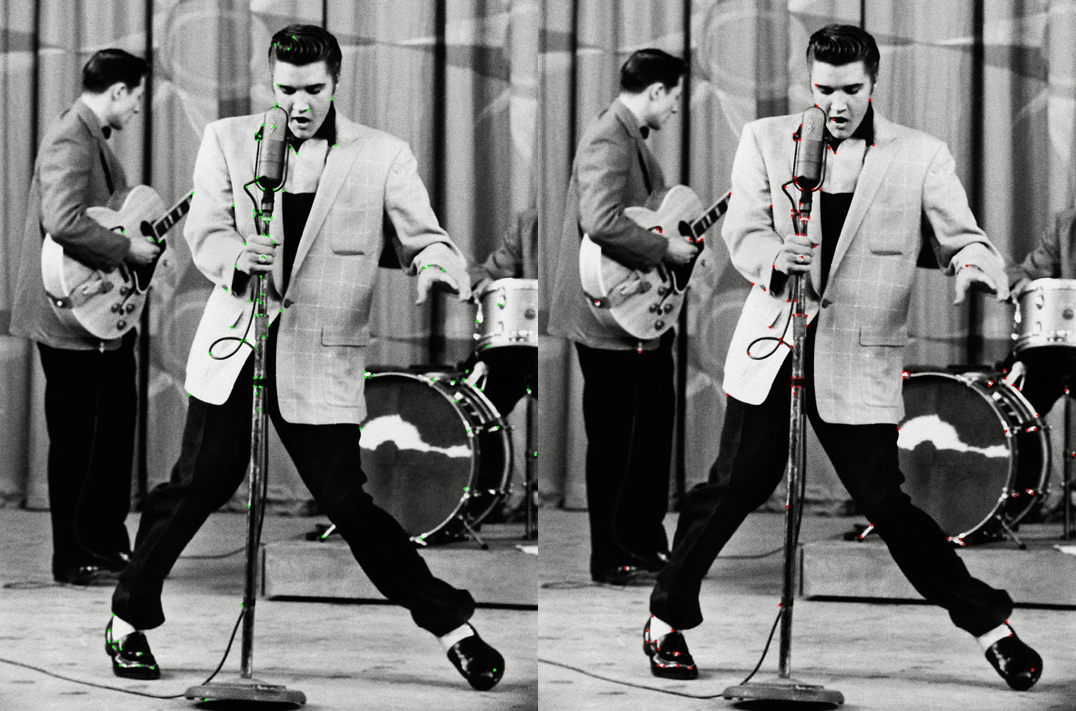

**Discussion:**

The parameters set for corner detection in both methods were the same, those parameters being max pixels of 100 with a pixel distance of 10 apart. For all 5 images, the top three intensities for corners where nearly identical or just ranked in a different order. For example, in AllmanBrothers.png the top-rated location for the cv2 function was the third ranked location for Harris Corner detector implementation, while the second ranked of the cv2 function was the top-rank of the Harris implementation. Looking at the comparison of the corner detection methods side by side they both land on the key features, for example the AllmanBrothers it’s the buttons and keys.

Code

Homework3.py:

import cv2

import numpy as np

import math

RED = (0, 0, 255)

GREEN = (0, 255, 0)

BLUE = (255, 0, 0)

def sort_by_max_values(matrix, threshold):

# Find all values greater than 0

max_value = np.amax(matrix)

rows, cols = np.where(matrix > max_value* threshold)

# Iterate over loc to create list of (r,c,i)

loc_list = [(r, c, matrix[r,c]) for r,c in zip(rows, cols)]

# sort by intensity

sorted_loc = loc_list.copy()

for i in range(0, len(sorted_loc)):

for j in range(0, len(sorted_loc)-i-1):

if (sorted_loc[j][2] < sorted_loc[j + 1][2]):

temp = sorted_loc[j]

sorted_loc[j]= sorted_loc[j + 1]

sorted_loc[j + 1]= temp

return sorted_loc

def filter_points_by_distance(points_list, distance):

# Get points that are greater than set distance apart

for idx1 in range(len(points_list)):

for idx2 in range(len(points_list)):

if idx1 == idx2:

pass

elif type(points_list[idx1]) == int or type(points_list[idx2]) == int:

pass

else:

r1 = points_list[idx1][0]

c1 = points_list[idx1][1]

r2 = points_list[idx2][0]

c2 = points_list[idx2][1]

d = math.dist((r1,c1), (r2,c2))

if d < distance:

points_list[idx2] = 0

# Remove all 0 from list

try:

while True:

points_list.remove(0)

except ValueError:

pass

return points_list

def harris_corner_detector(img, maxCorners, alpha, minDistance):

# Find X and Y gradient components

ix = cv2.Sobel(img, cv2.CV_32F, 1, 0)

iy = cv2.Sobel(img, cv2.CV_32F, 0, 1)

# Find M_bar components by applying gaussian blur to M components

kernal = (5,5)

ix_sq_bar = cv2.GaussianBlur(np.multiply(ix,ix), kernal, cv2.BORDER_DEFAULT)

iy_sq_bar = cv2.GaussianBlur(np.multiply(iy,iy), kernal, cv2.BORDER_DEFAULT)

ix_iy_bar = cv2.GaussianBlur(np.multiply(ix,iy), kernal, cv2.BORDER_DEFAULT)

iy_ix_bar = cv2.GaussianBlur(np.multiply(iy,ix), kernal, cv2.BORDER_DEFAULT)

#

#M_bar = np.array([[ix_sq_bar, ix_iy_bar],

# [iy_ix_bar, iy_sq_bar]])

# Formula: Q = det(M_bar) - alpha*(trace(M_bar))^2

M_bar_det = np.multiply(ix_sq_bar,iy_sq_bar) - np.multiply(ix_iy_bar,iy_ix_bar)

trace = np.multiply(ix_sq_bar + iy_sq_bar, ix_sq_bar + iy_sq_bar)

Q = M_bar_det - alpha*trace

# Get all corner coordinates that are minDistance away

threshold = 0.5

sorted_loc = sort_by_max_values(matrix = Q, threshold = threshold)

corner_coord_ = filter_points_by_distance(points_list = sorted_loc, distance = minDistance)

# Keep doing this until max Corners is met

print(f"Loading... finding top {maxCorners} corners")

while len(corner_coord_) < maxCorners:

sorted_loc = sort_by_max_values(matrix = Q, threshold = threshold)

corner_coord_ = filter_points_by_distance(points_list = sorted_loc, distance = minDistance)

threshold = threshold - 0.01

print(f"Finally got {maxCorners}!!!")

# Trim down the extras

corner_coord_ = corner_coord_[:maxCorners]

# remove intensity from sorted_loc

corner_coord = [(r,c) for r,c,_ in corner_coord_]

return corner_coord

def main(filenames):

for filename in filenames:

# Read in IMG as color and greyscale

img1 = cv2.imread(filename)

img2 = img1.copy()

img_grey1 = cv2.imread(filename,0)

img_grey2 = cv2.imread(filename,0)

# Find 100 corners using CV2

corners_1 = cv2.goodFeaturesToTrack(img_grey1

, maxCorners = 100

, qualityLevel=0.05

, minDistance=10)

# Part 1d: Print to console filename and x,y coord of top 3 corner points

print("Top 3 corners using cv2.goodFeaturesToTrack")

print(f'Filename: {filename}')

for i in corners_1[:3]:

x = i.ravel()[0]

y = i.ravel()[1]

print(f'(x,y): ({x},{y})')

corners_1 = np.int0(corners_1)

for i in corners_1:

x,y = i.ravel()

cv2.circle(img1, (x,y), 3, GREEN, -1)

# Show Image

cv2.imshow(f'CV_corners_{filename}', img1)

cv2.waitKey(0)

cv2.imwrite(f'CV_corners_{filename}', img1)

# Find 100 corners using homemade Harris Corner Detector

corners_2 = harris_corner_detector(img = img_grey2

, maxCorners = 100

, alpha = 0.05

, minDistance = 10)

# Part 1d: Print to console filename and x,y coord of top 3 corner points

print("Top 3 corners using Harris Corner Method")

print(f"Filename: {filename}")

for i in corners_2[:3]:

x = i[1]

y = i[0]

print(f'(x,y): ({x},{y})')

for r,c in corners_2:

cv2.circle(img2, (c,r), 3, RED, -1)

# Show Image

cv2.imshow(f'Harris_corners_{filename}', img2)

cv2.waitKey(0)

cv2.imwrite(f'Harris_corners_{filename}', img2)

# Merge the two images

img_combined = np.concatenate((img1,img2), axis = 1)

cv2.imshow(f'Combined_{filename}', img_combined)

cv2.waitKey(0)

cv2.imwrite(f'combined_{filename}', img_combined)

if __name__ == "__main__":

filenames = ['AllmanBrothers.png'

, 'CalvinAndHobbes.png'

, 'Chartres.png'

, 'Elvis1956.png']

main(filenames)